

SCC306 Internet Applications Engineering

Coursework Element 3: Accessibility

**Nicholas Race & Matthew Broadbent**

|  |  |
| --- | --- |
| **Name:** | **Lewis Allen** |
| **Student Number:** | 34009965 |

# Introduction

In this workbook you are expected to demonstrate your finished accessible website. You need to document each accessible feature you have implemented alongside code extracts that demonstrate ***how*** you have implemented them, and **evidence** of the effectiveness of the change.

For any additional features you may have added, show and explain using code and screenshots. Finally, explain how the feature improves the accessibility of the website.

To submit this coursework, upload your website to Moodle (include index.html, style.css, this lab book document, and other files you may have used). Please use ZIP to archive the files as a single submission.

# Accessibility feature 1

Contrasting colours

Colour contrasts can affect the visually impaired, this including colour blindness, and cognitive impairments. Devices will lower colour support also take advantage of this accessibility feature.

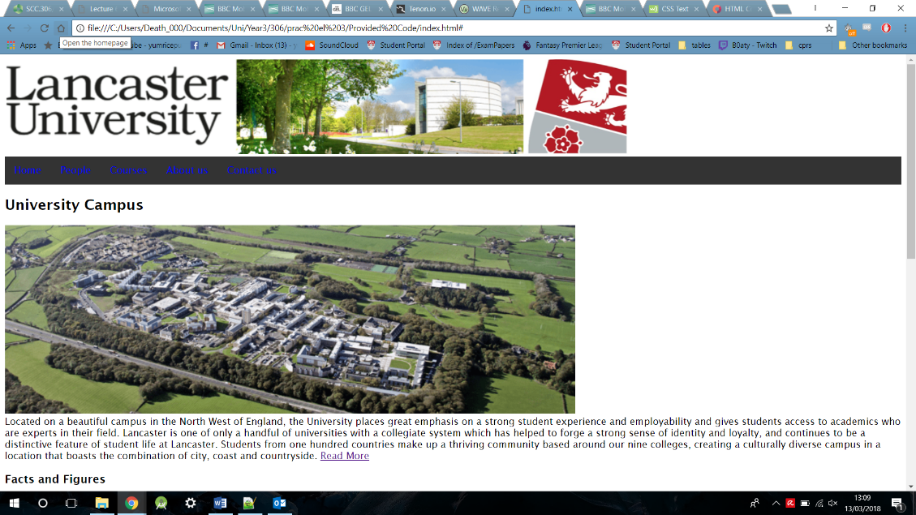As seen in the image below the navigation bar is a dark grey tone and the links in the navigation bar have a colour of blue. From this screen the text is not very visible and shows poor colour contrasting.

The second screen shot shows the updated site to have a better colour scheme for both the navigation bar and the navigaiton links. The naivigation bar is now a lighter grey and the navigation links are of a black font.

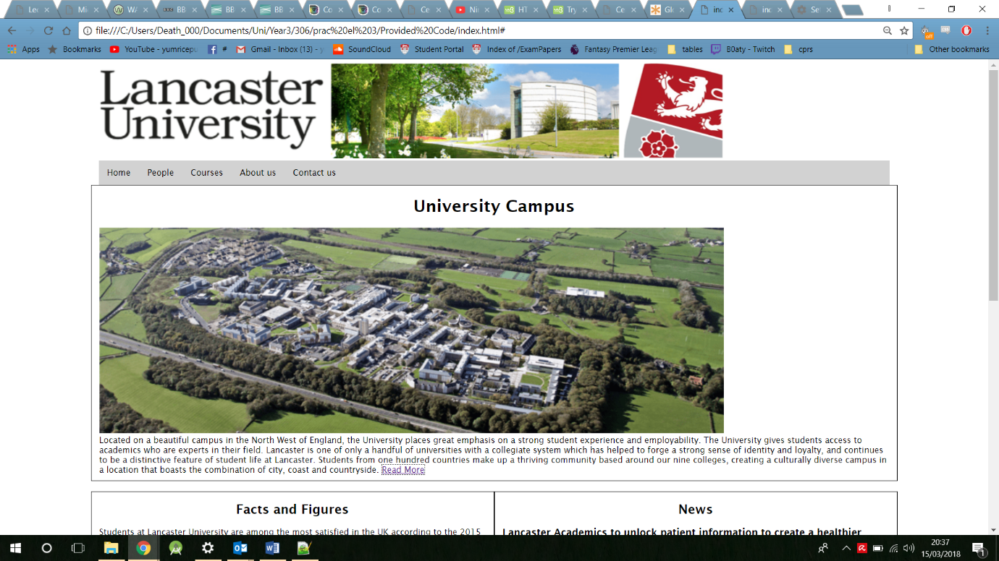

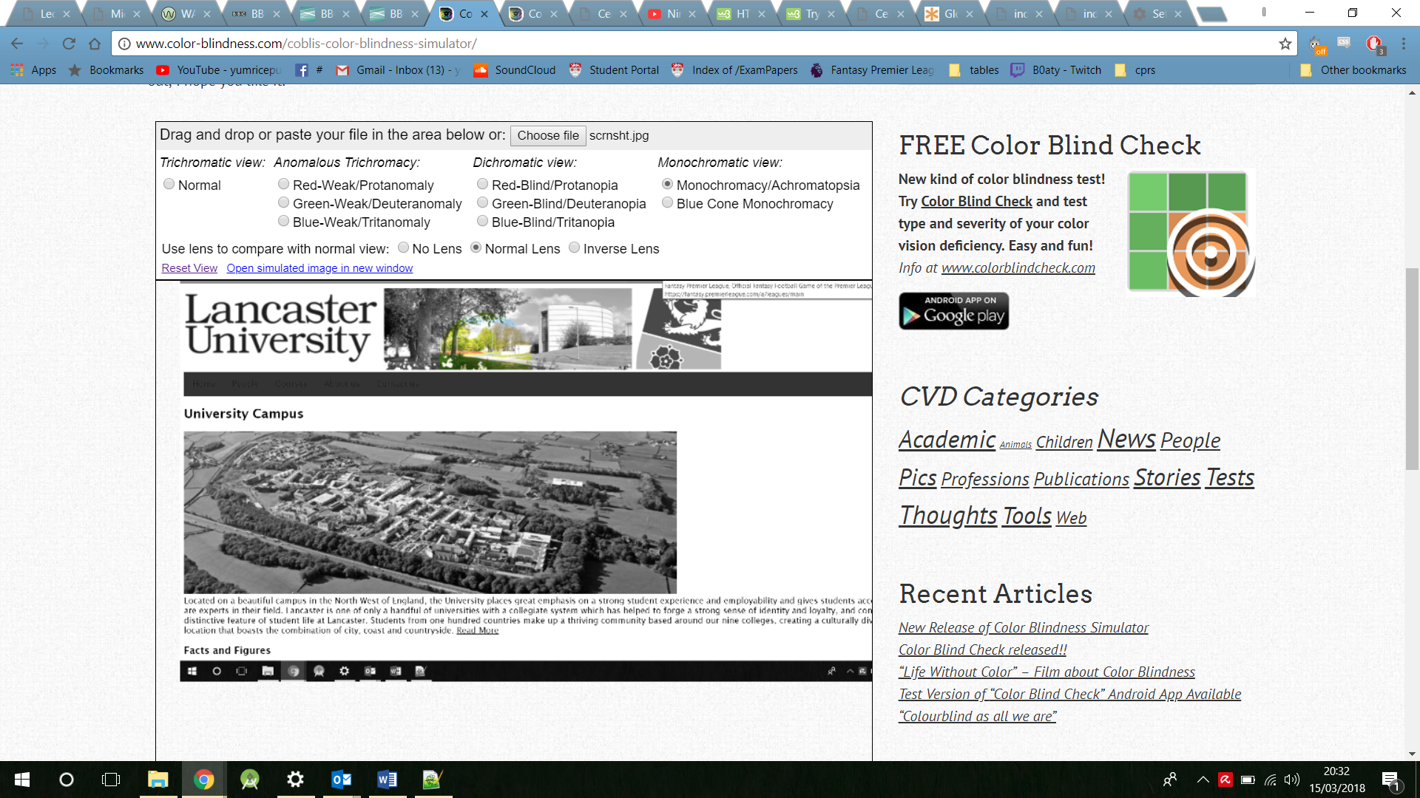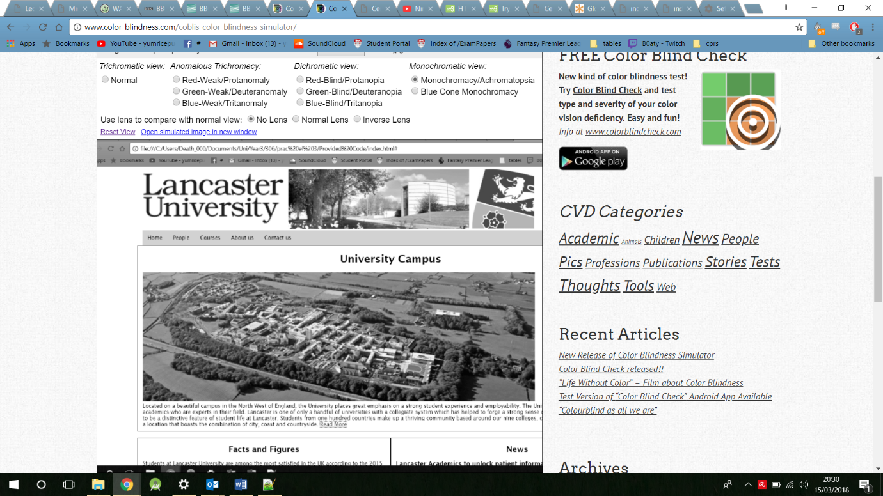When these two sites are viewed over in a colour blindness simulator, the results show that the updated site is far clearer than the original, as the navigation links are especially dark, against a dark background.

Original site in a colour blindness simulator

Updated site in a colour blindness simulator

This accessibility feature was completed by changing the colour of both the navigation bar and navigation links CSS. The CSS code for the navigation bar background can be seen on the left and the navigation links colour can be seen on the right.

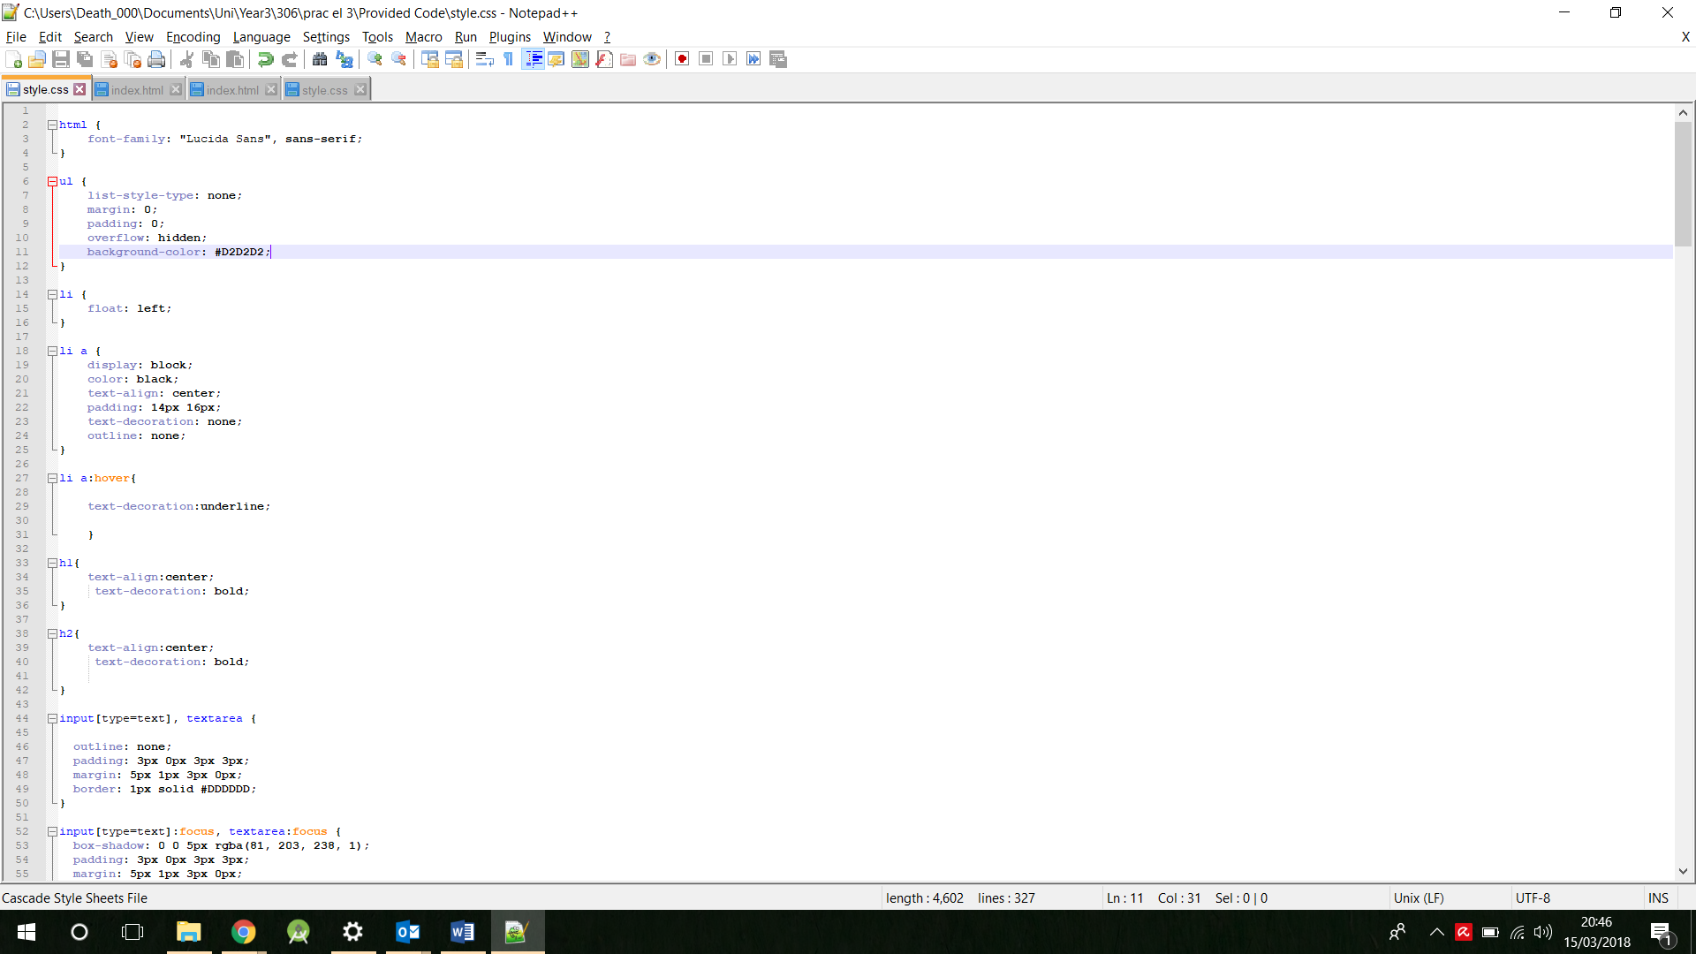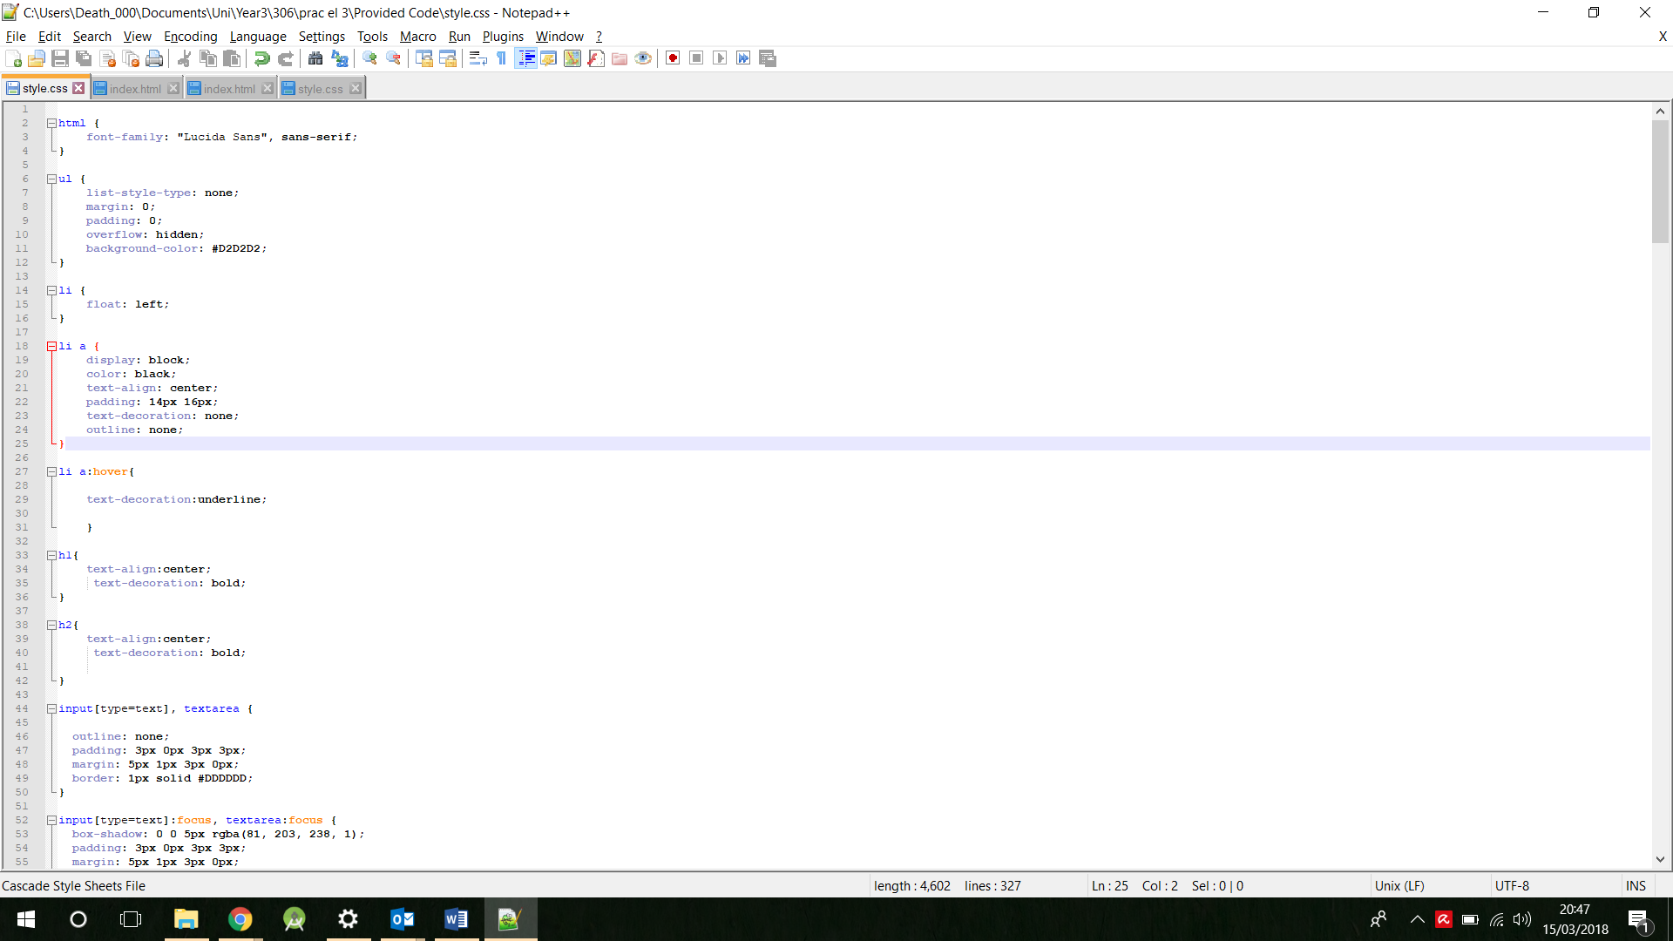

# Accessibility feature 2

Image alternatives

Image alternatives are an accessible feature used to briefly describe what the image describes, for those who may have visual impairments. Screen reader have ability to recognise the image alternatives and convey the message to the user.

These screen shots provide the description of the alternative text in the images of the Lancaster university site. The left image is the original without image alternatives, this screen shot shows no text next to the images. However, in the updated screen shot on the right some text describing the images appears to the right of where the image should be, proving that it has an alt tag.

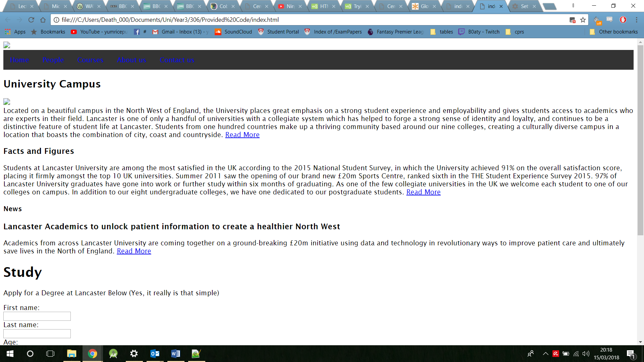

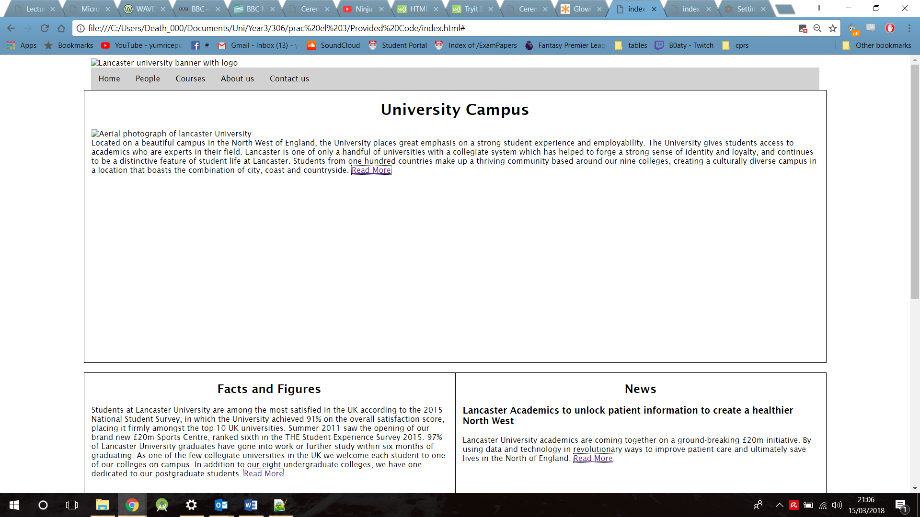

These alternative images were added by including an alt tag in the html source code.

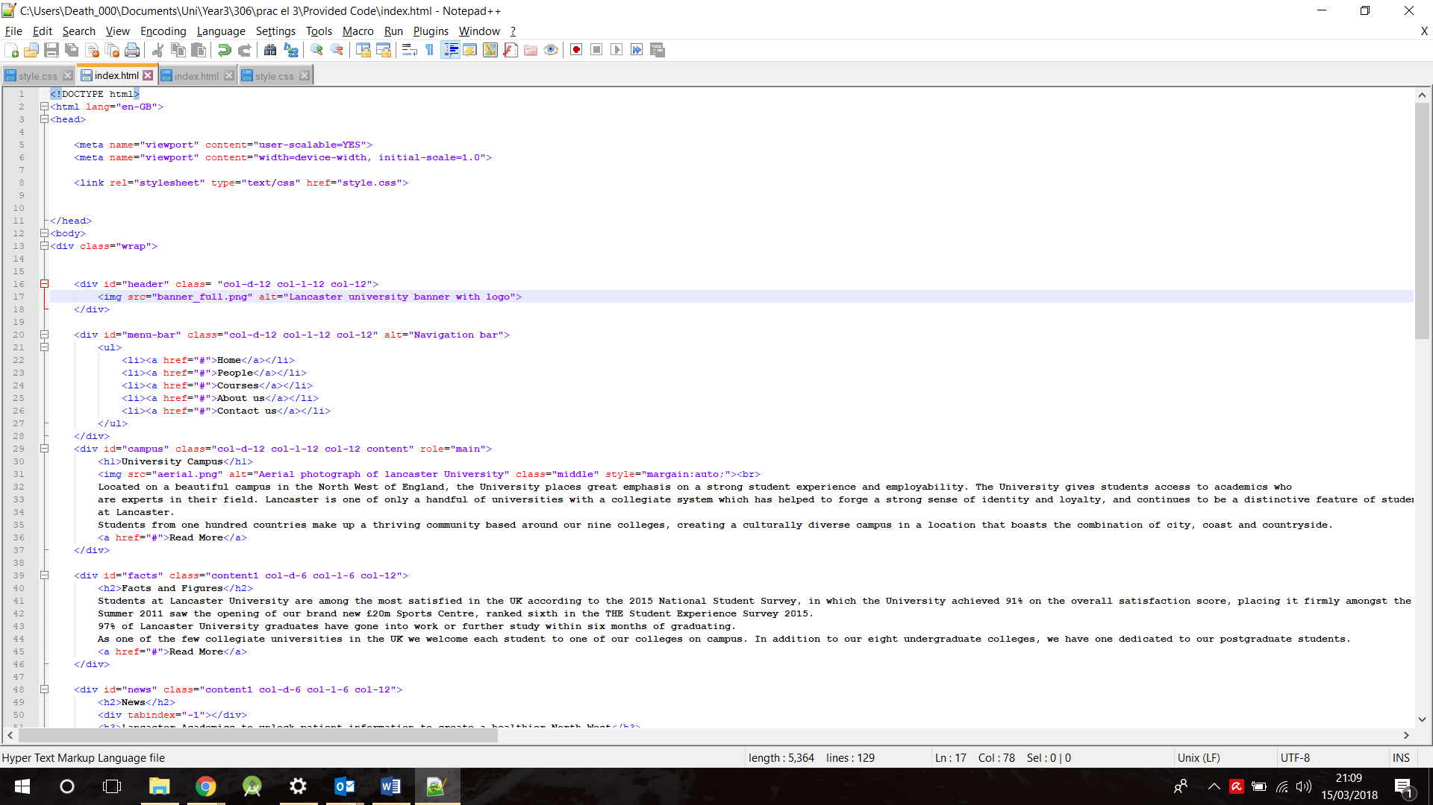

# Accessibility feature 3

Plain English is used in order to speak to every type of individual. As this website is for Lancaster university the audience could be individuals of another country with basic English skills or those who have a disability and may not be able to understand the text as well.

To combat this, plain text is used as an accessibility feature to make sentences smaller with an easy to read structure.

“Academics from across Lancaster University are coming together on a ground-breaking £20m initiative using data and technology in revolutionary ways to improve patient care and ultimately save lives in the North of England. Read More”

“Lancaster University academics are coming together on a ground-breaking £20m initiative. By using data and technology in revolutionary ways to improve patient care and which could save lives in the North of England. Read More”

These quotes are taken from both the original site and the updated site. The first quote is from the original site which contains complex dialog in large sentences. The second quote contains language from the updated site to include plain English, this can be notice by the shortening of sentences with easily understandable English through active verbs.

By adding this feature, it removes any ambiguity from the text whilst still getting the addressed point across.

# Accessibility feature 4

Heading structure

By including a heading structure feature this allows the site to distinguish the page from the sub sections giving a better sense of navigation. The content of the text must be relevant to the heading or subheading otherwise individuals may get confused with the structure.

A page full of heading is too much however as they are used to navigate around the site, so by including too many heading this takes away the role of importance and structing they provide. No more than one <h1> heading should be used as this is the highest heading, the top of the structure.

This screen shot shows the original site, which contains multiple amounts of <h1>’s and an unordered structure to the headings as some are lower in the hierarchy than they should be.

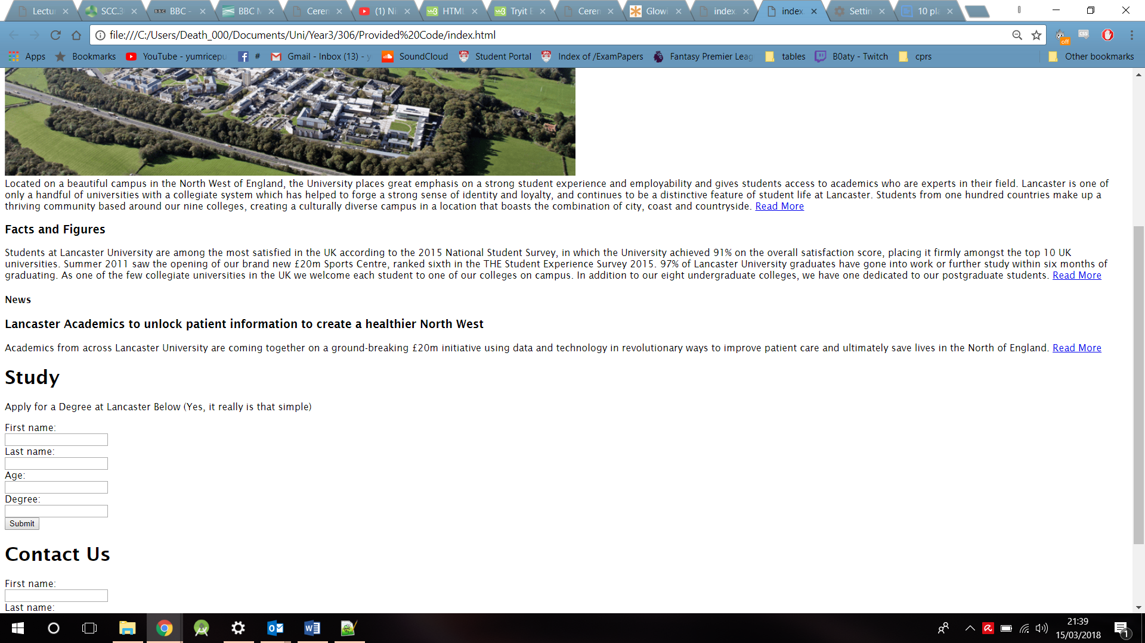

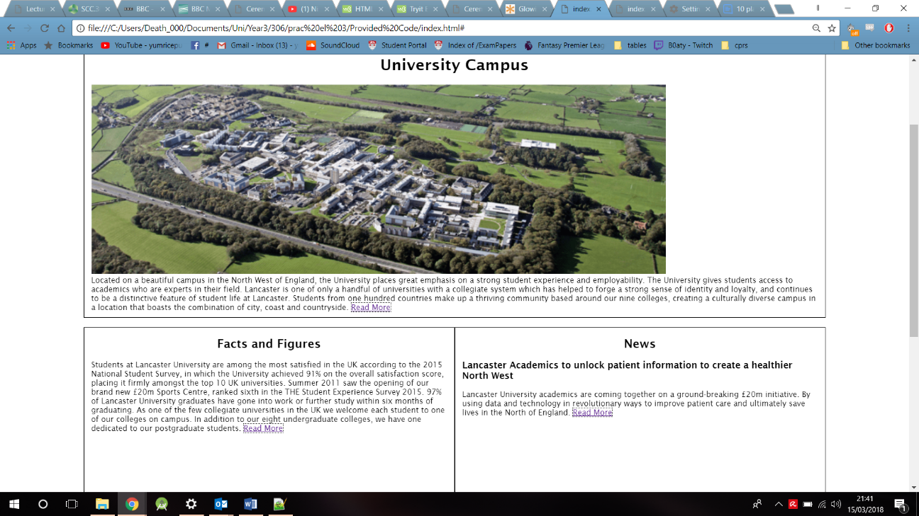The updated site shows the heading structure to be fixed, with one highest heading <h1> at the top of the site, the following sub headings are given to each new subsection and anything below will be a subsection of that subsection. These headings are given the CSS decoration of being bold as if they were to be underlined they may be confused with links to new pages.

# Accessibility feature 5

Error control

This is an accessibility feature used across multiple areas. The need for this feature is due to the guidance it provides users. This is an important feature because it guides a user on where to go, what to do and where to go next. For example, by including a required method into an input tag, this will signify that the user cannot continue without filling his specific area in. By implementing this feature, it minimises possible faults that can be found, straightening the path on which the use is to follow.

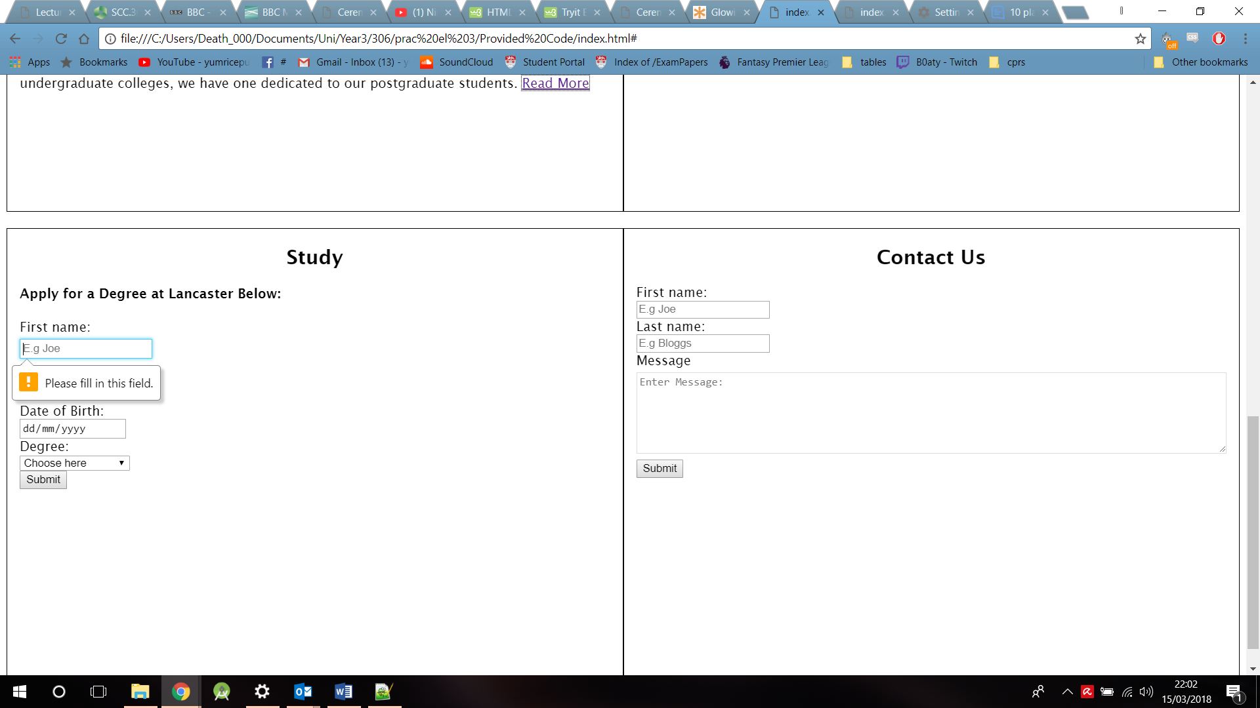

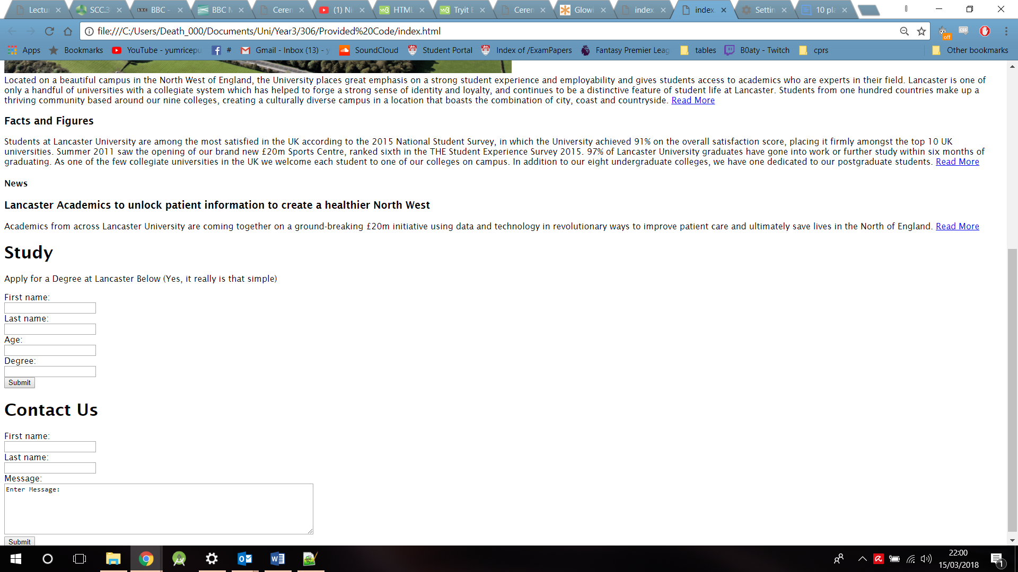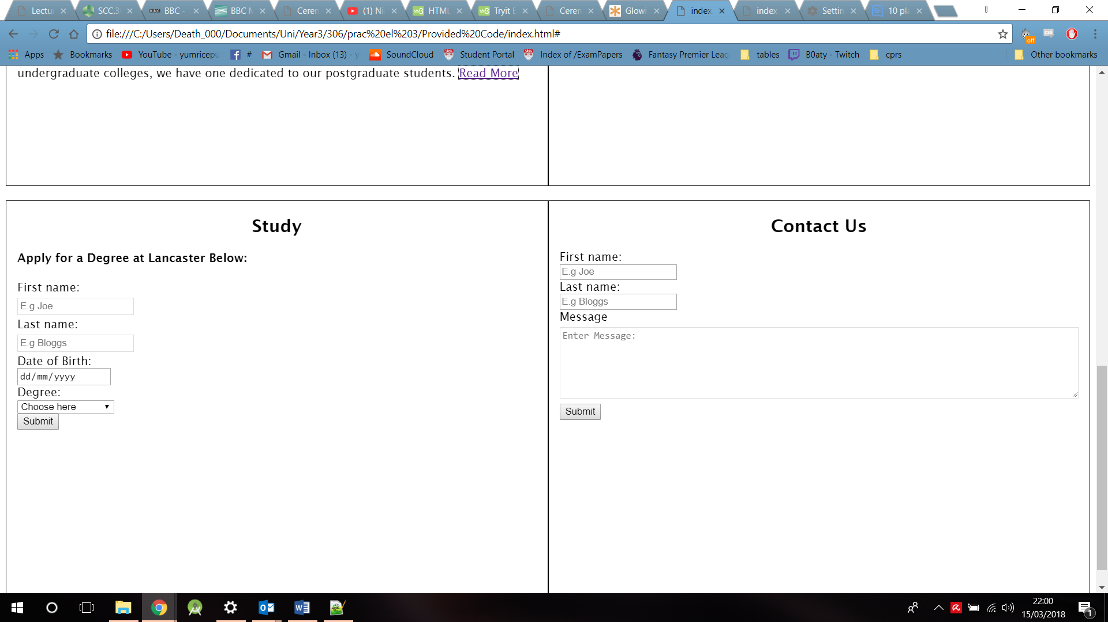

When comparing the original site(on the right) to the updated(on the left) there are many things that can be seen that help the user complete the form. With the updated site on the left and the original on the right. The updated site has a place holder on each text box to guide the user on what information must be provided as seen in first name and Last name with Joe and Bloggs.

A date type is used within the date of birth section, disallowing any other form of information or text to be entered in to this field, avoiding incorrect formats. The degree section allows users to select a certain degree from the drop-down box, in case the user does not know the exact specification of the course.

If the user has not filled out each section the updated site will not submit the form until each field is filled in, the field will show if it has not been completed with a popup box. The original site however would let you enter any text and however much and submit when asked.

The code below describes the study form html, which displays the required method, the select tag for the dropdown box, the place holders for the grey text and the date input type with a minimum age and a maximum age.

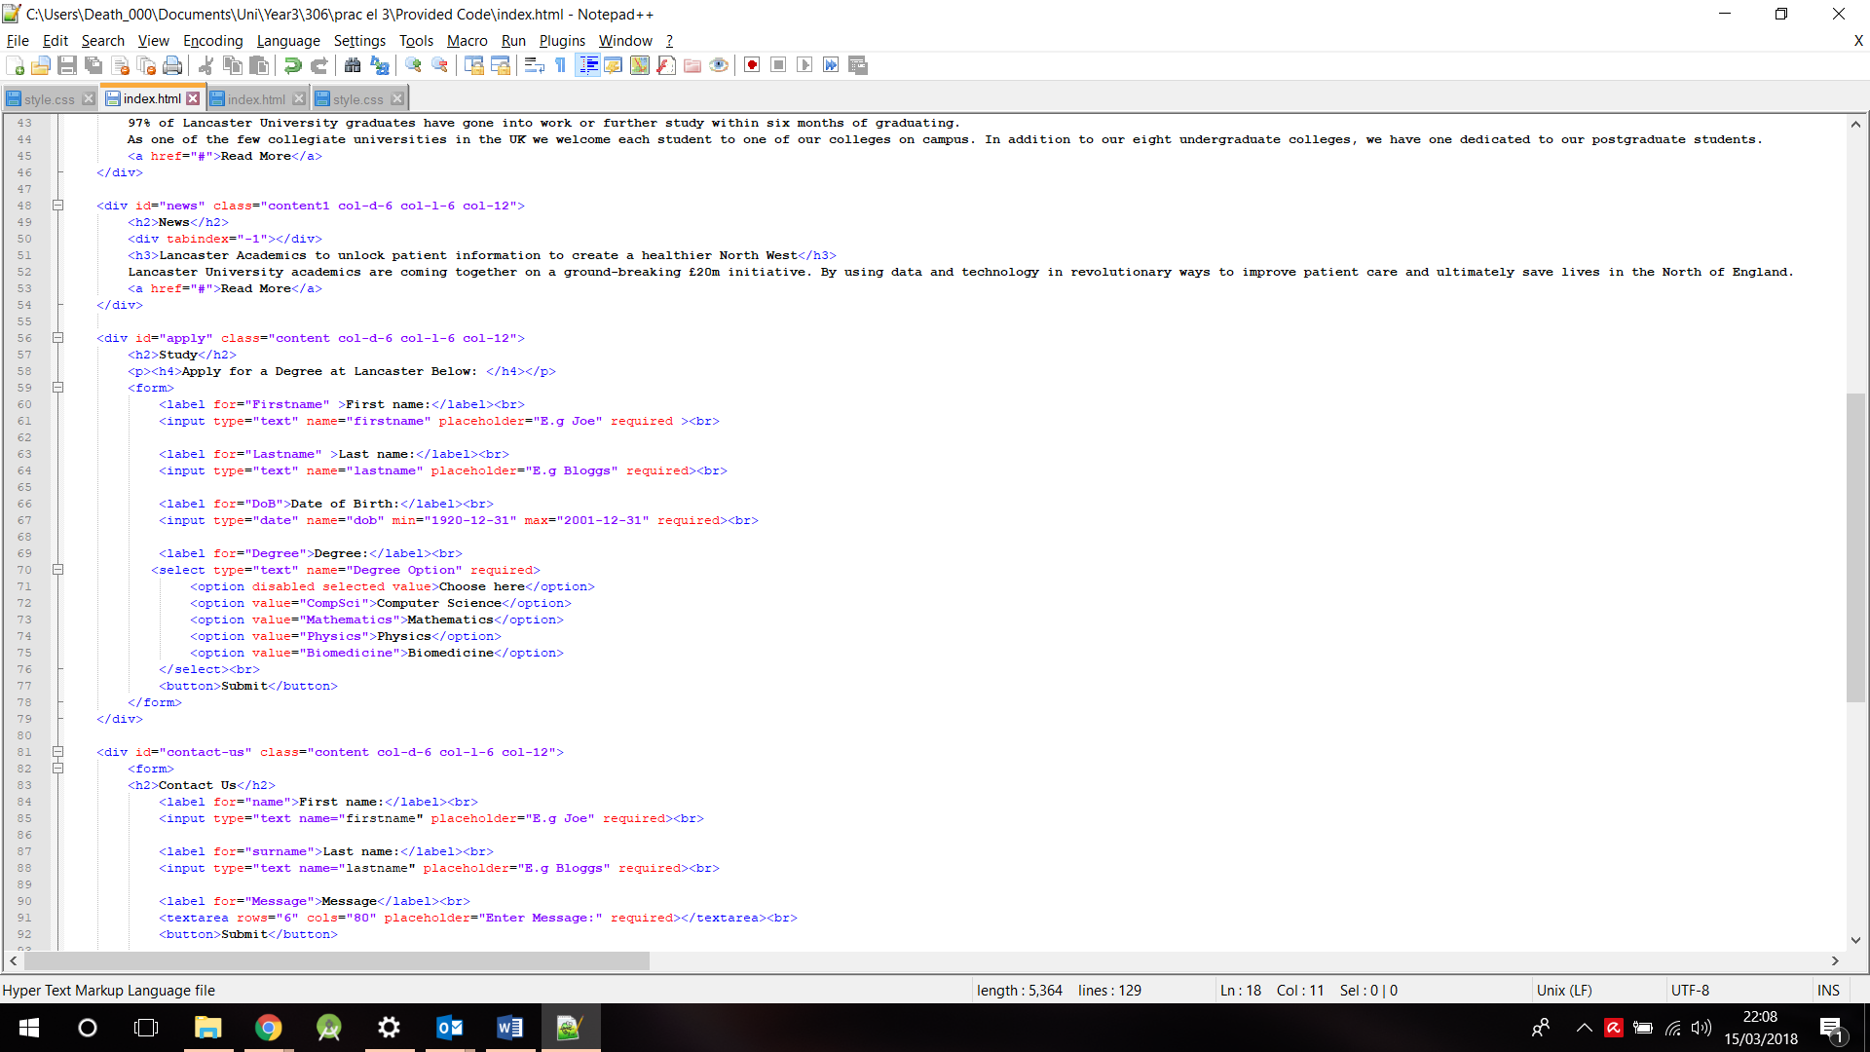

# Accessibility 6

Visible focus

This is an accessible feature that allows users to keep track of where they are in the content, by including highlights or effects where pointed to this gives the user the understanding of where they are and what the content might do. For example, by hovering over a certain area will change what the user sees slightly.

Within the updated site the areas that contain a visible focus either gain a border around the area or display a decoration of underlining to identify that this is a link or an interactive area. The main reason to why this is done is to provide guidance to the user, if ever they get lost within in the specific content.

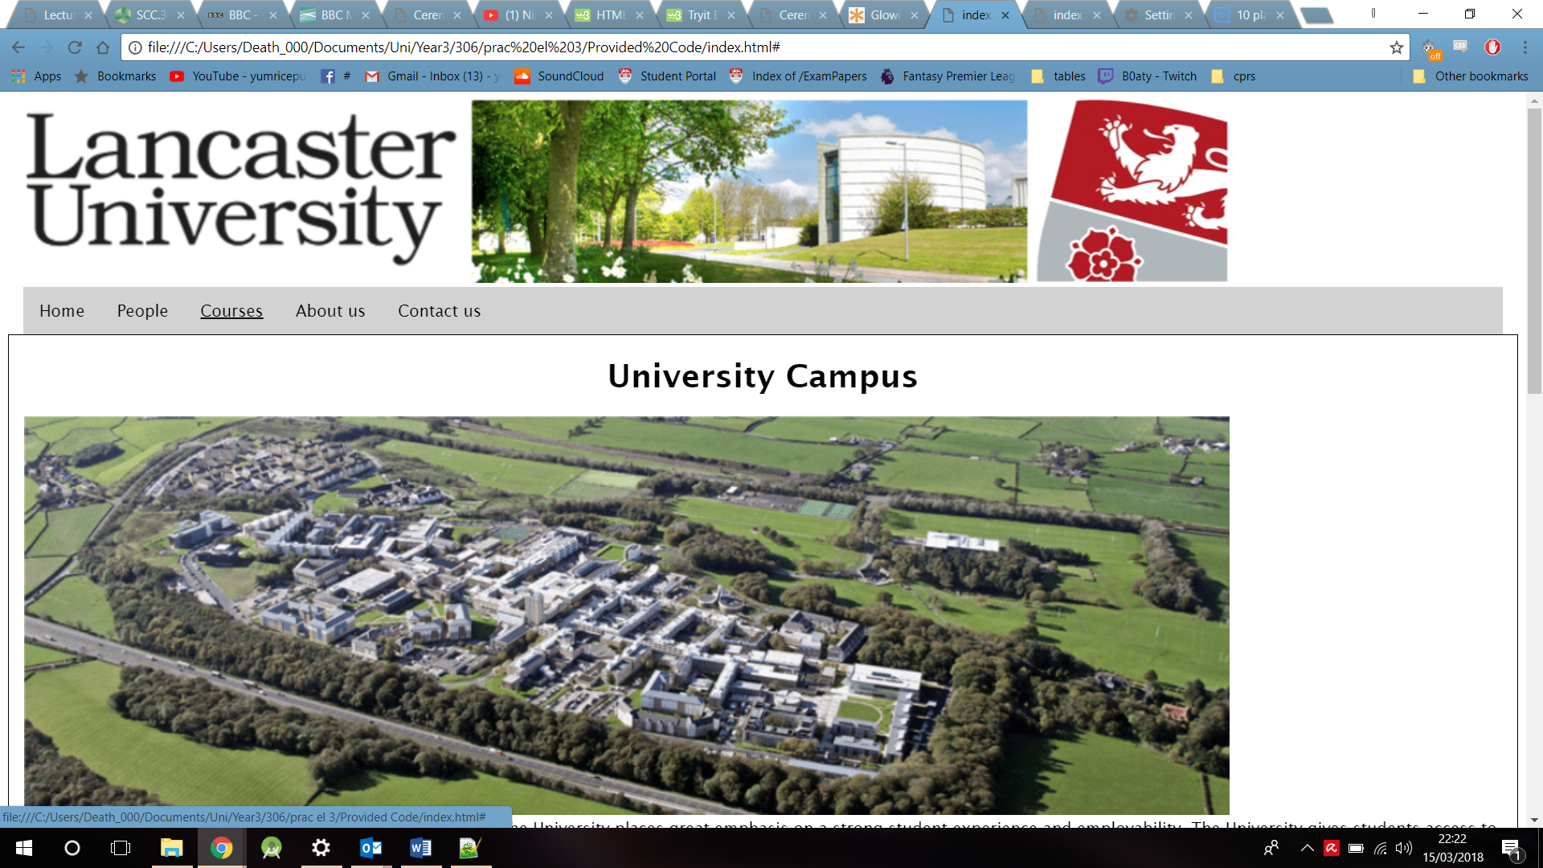 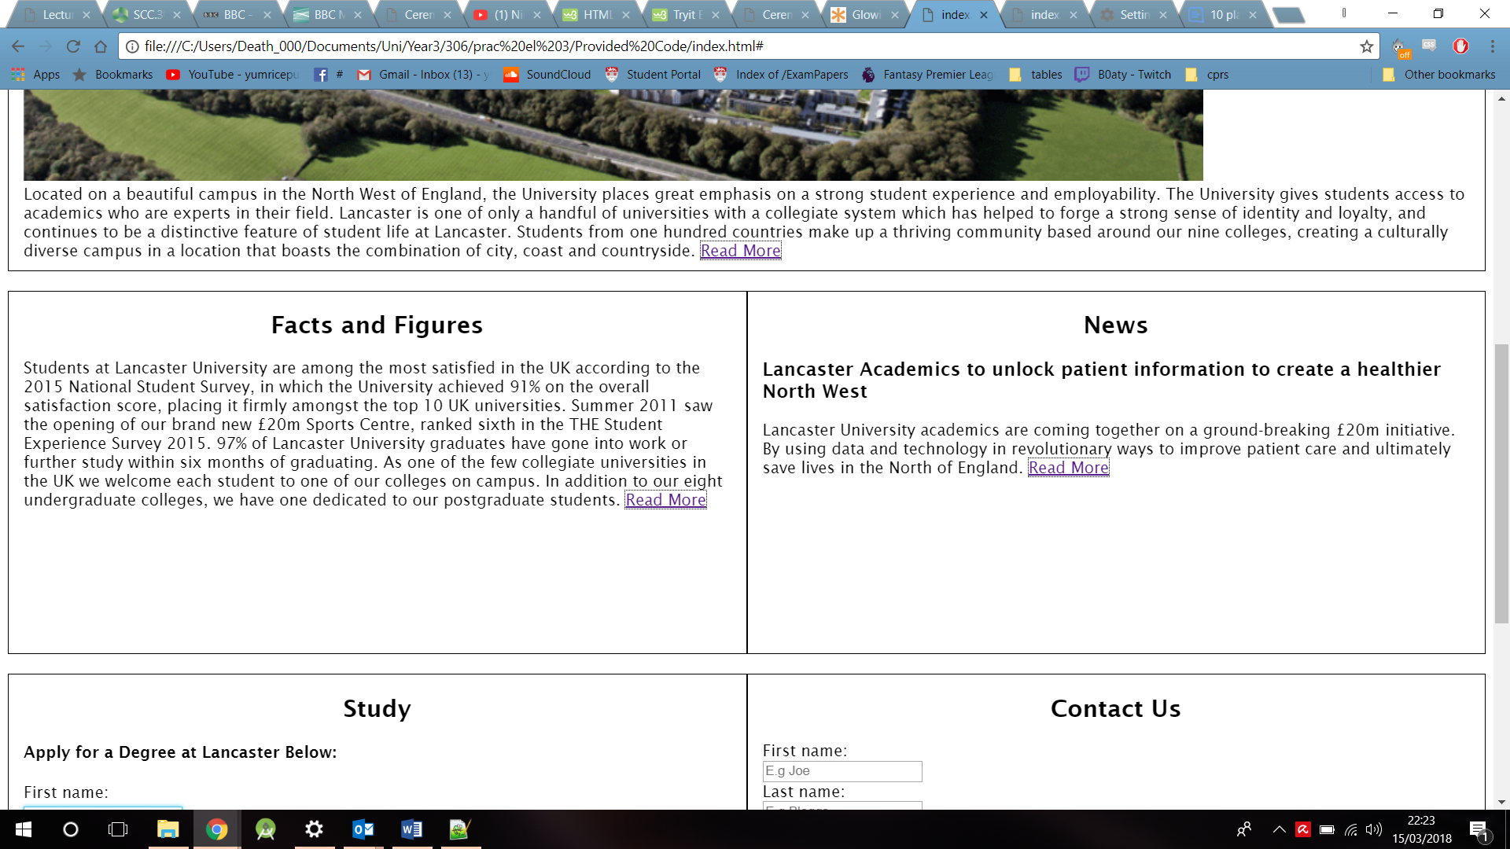 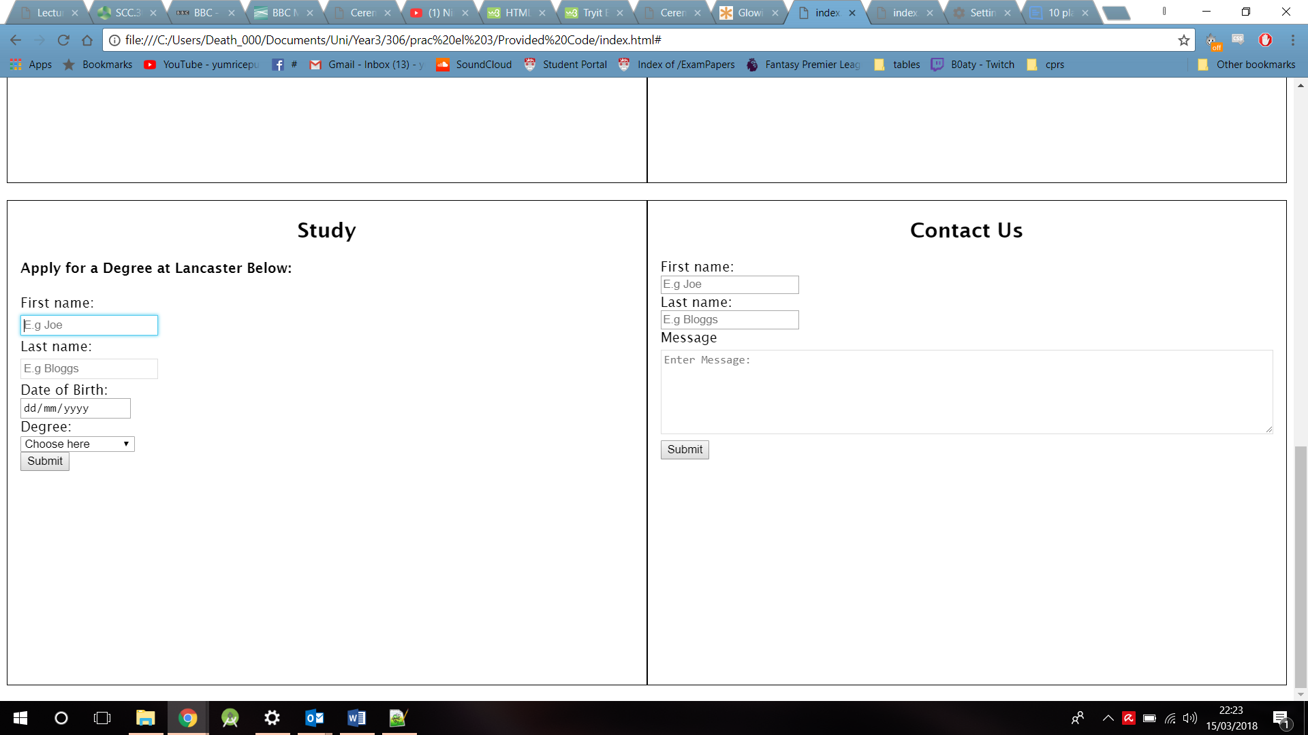

The code provided below shows how these elements of this feature were added into the CSS. A hover feature was added to the tag surrounding the navigation links. A blue border was added to the input type texts with specific margins. A thin black dotted outline was added to links embedded into a paragraph to distinguish this link form plain text.

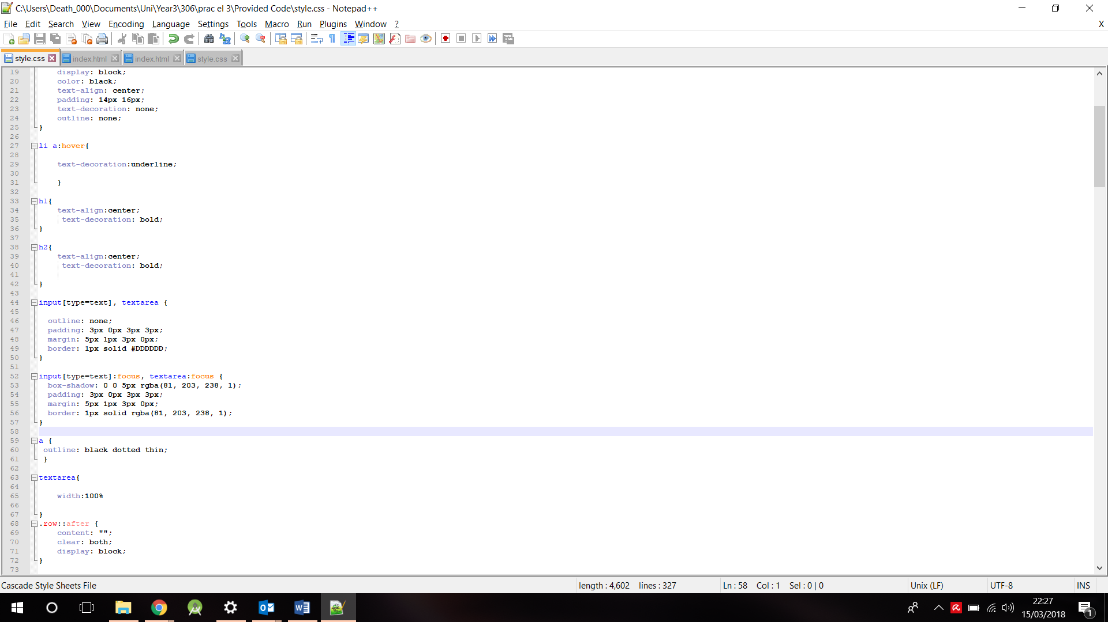

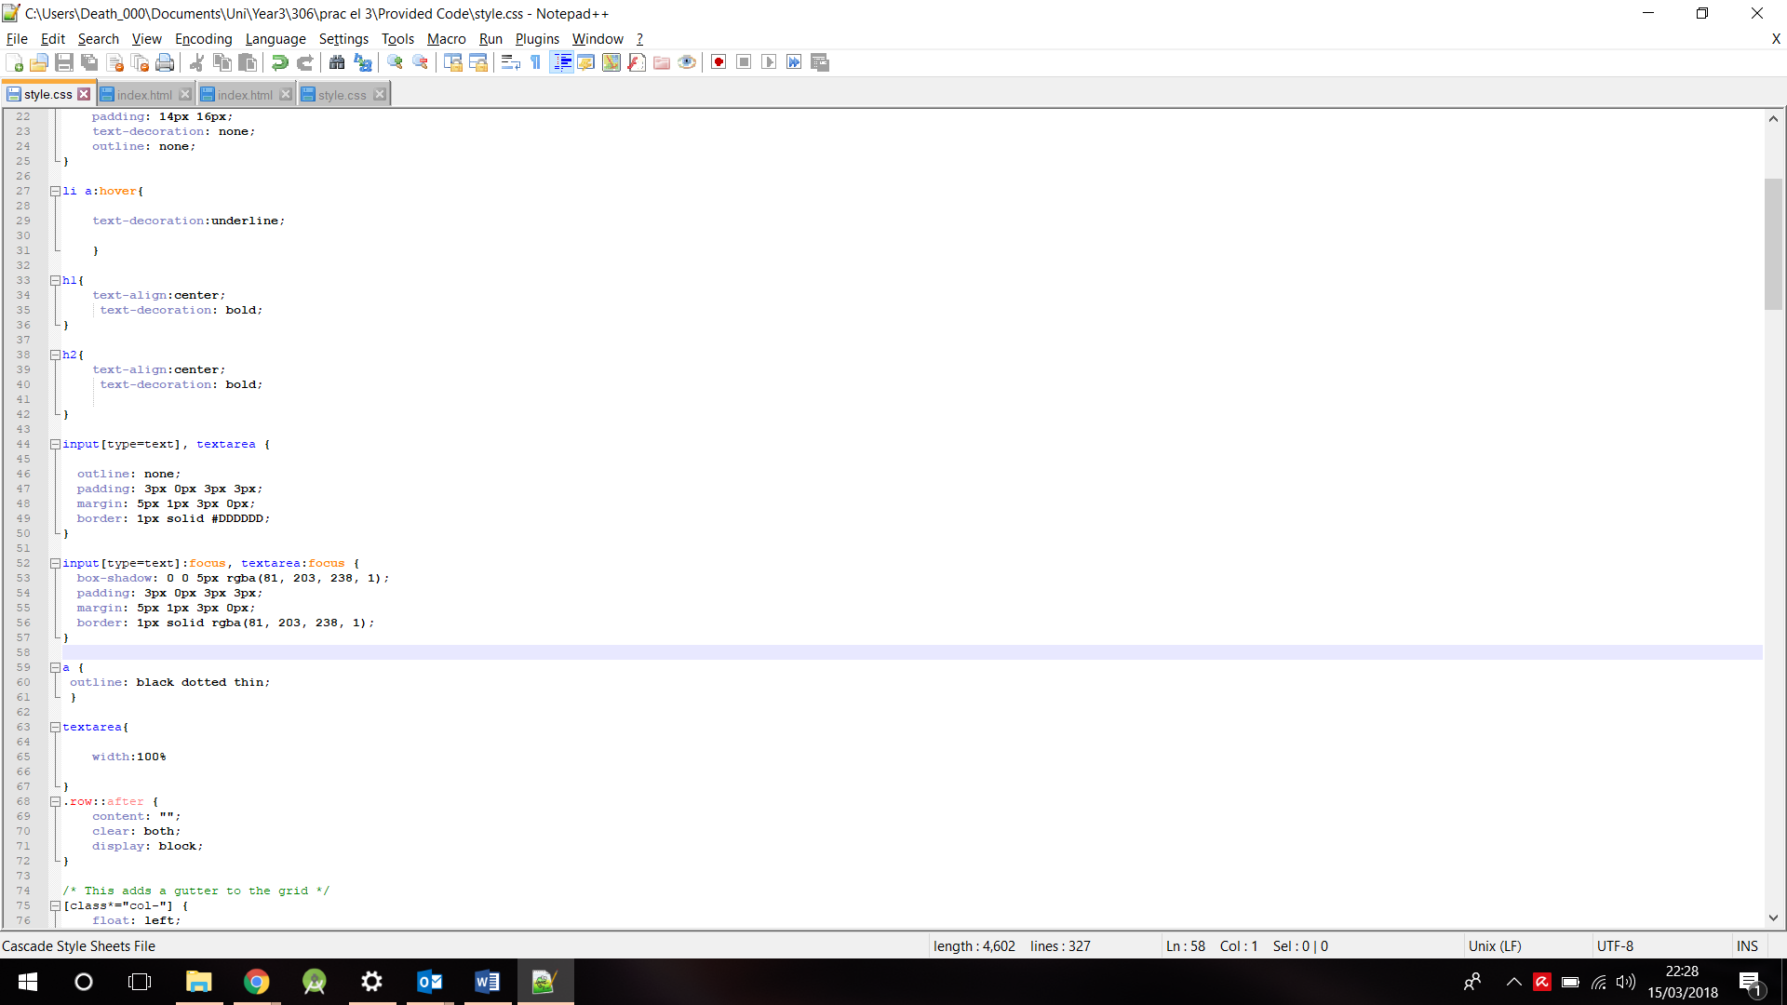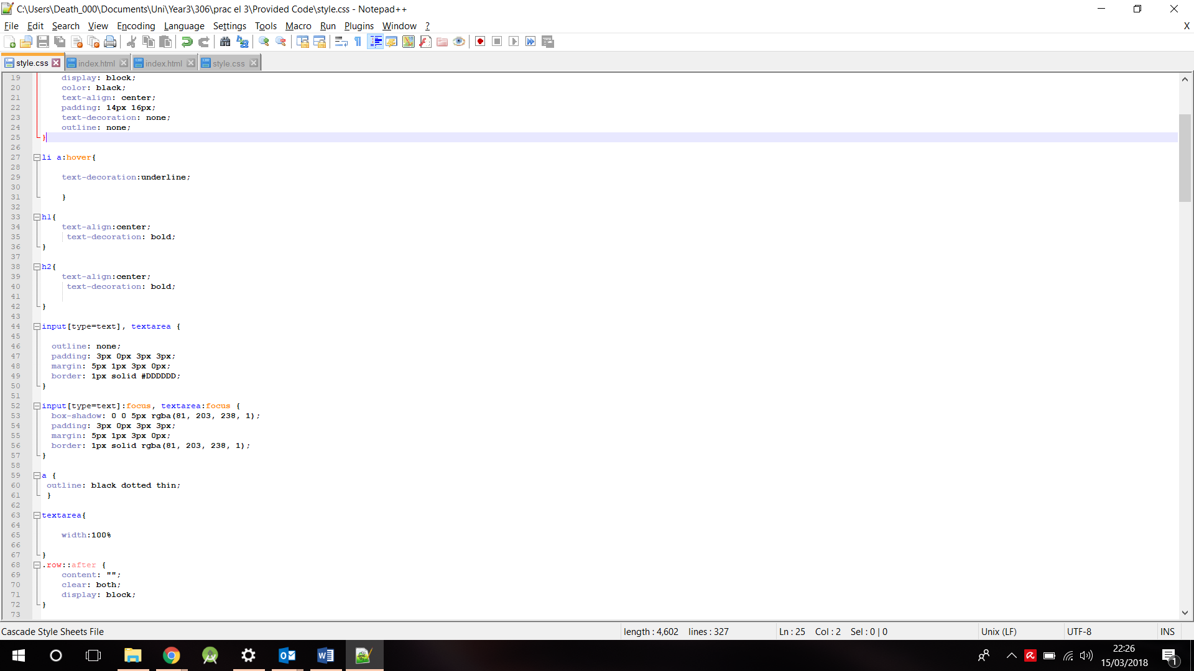

# Accessibility feature 7

Indicating language

By including this feature this allows the main language of the page to be specified. Assistive technologies like screen readers can support different languages, which include appropriate pronunciation. If the language was not indicated and was written in Spanish the screen reader will read this with English pronunciation, which in essence is not what the user will be expecting.

The screen shot of the code below describes how the language is indicated. This is included on to the html tag. Within this tag the language is defined as “en-GB” which stands for English, Great Britain to distinguish it from American English. With this the screen reader will pronounce in the provide language.

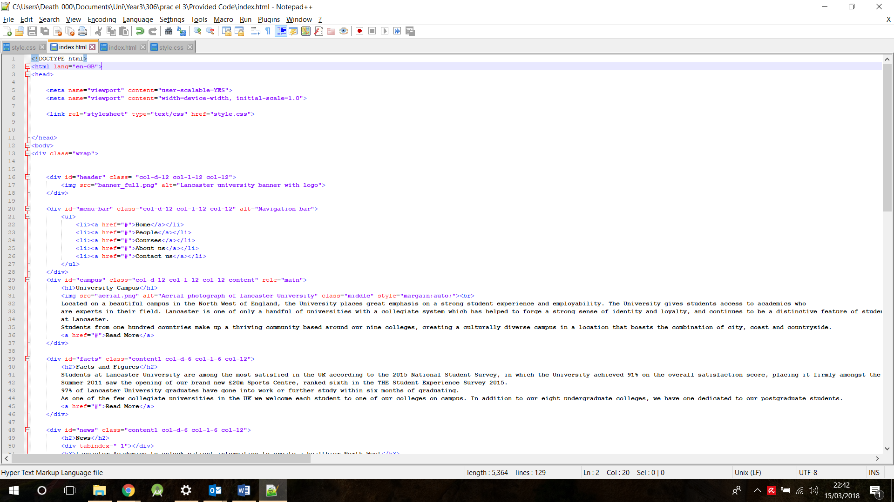

# Accessibility feature 8

Multiple platforms:

By including the ability to host the site over multiple platforms this provides accessibility to all types of users with different types of device. By providing a structure to each device this will allow the site to maintain its readability amongst users

Through the use of media queries, the site can be set to change when it reaches a certain screen size which is determined by the amount of pixels for example the maximum width of a phone. Within these media queries we can set the content of the page to adapt to this size.

These are applied by implementing:  
@media only screen( max/min-width: amount of pixels){ content}.

This is a rule to include a block of CSS properties only if a certain condition is true.

Without media queries there would be no difference in the layout of the site, everything would just be scaled down to be visible to the user. The site may not function properly to a user on a smaller device, which will results in hindering the user.

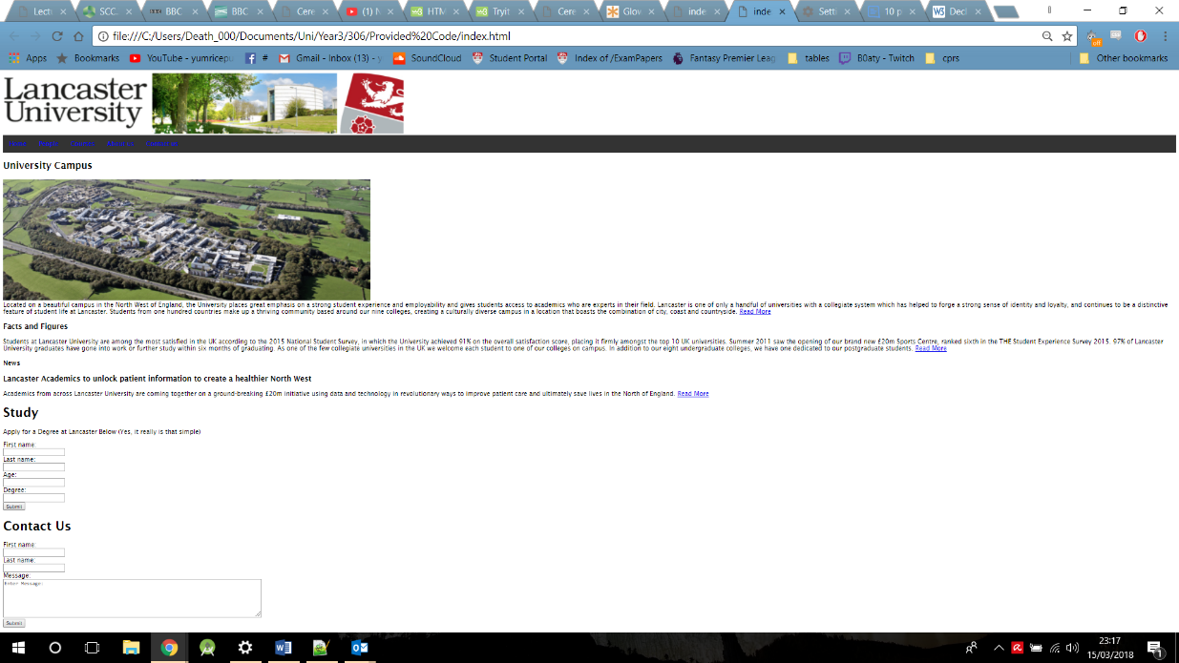

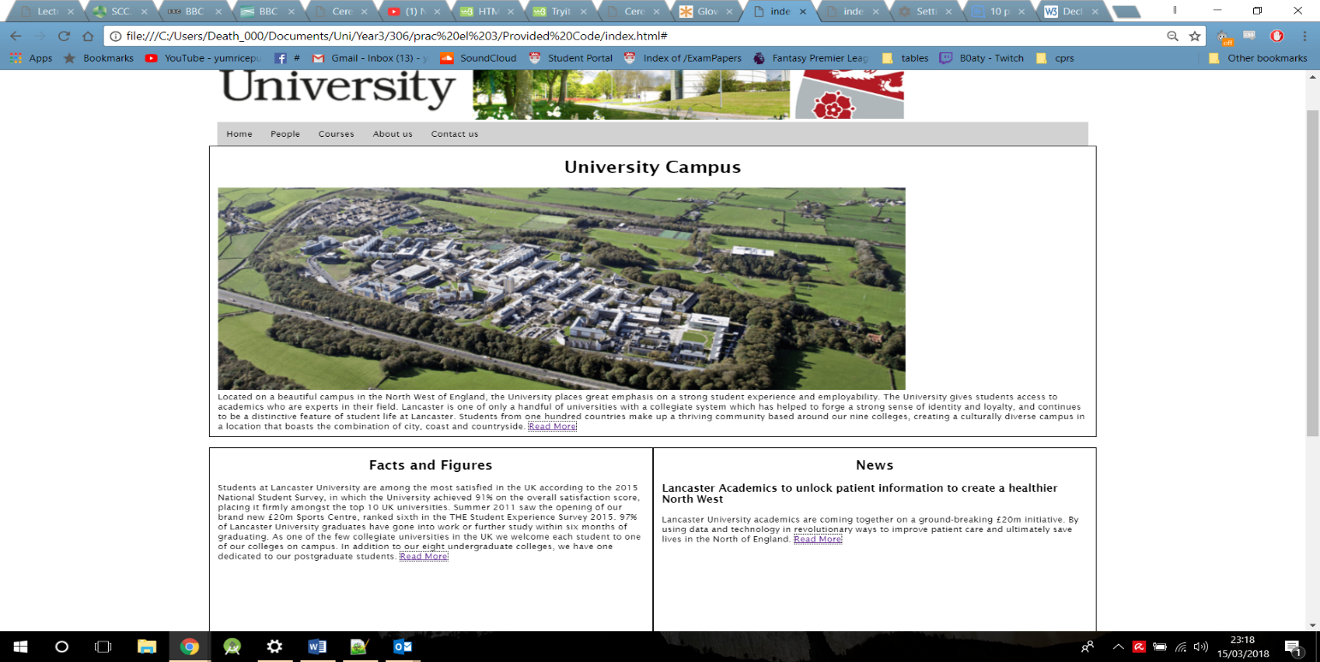

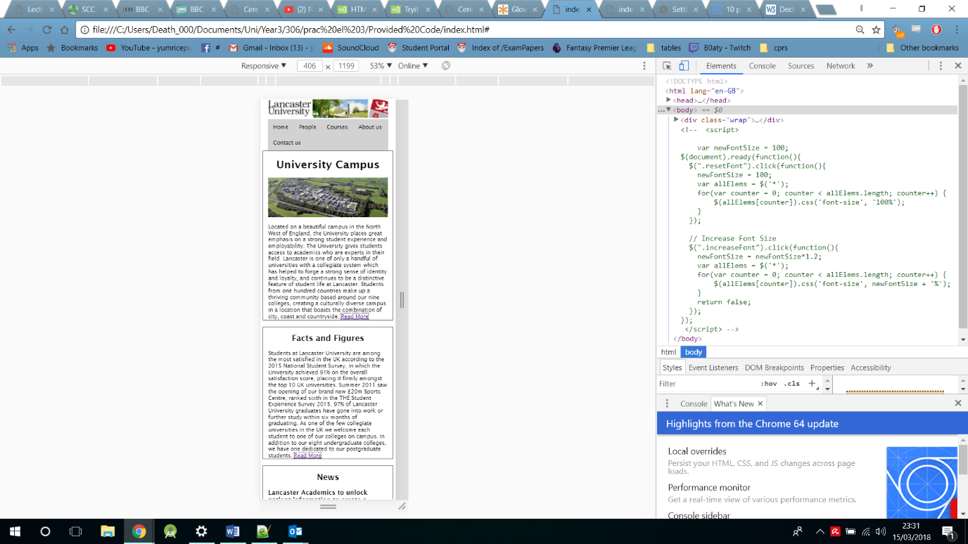 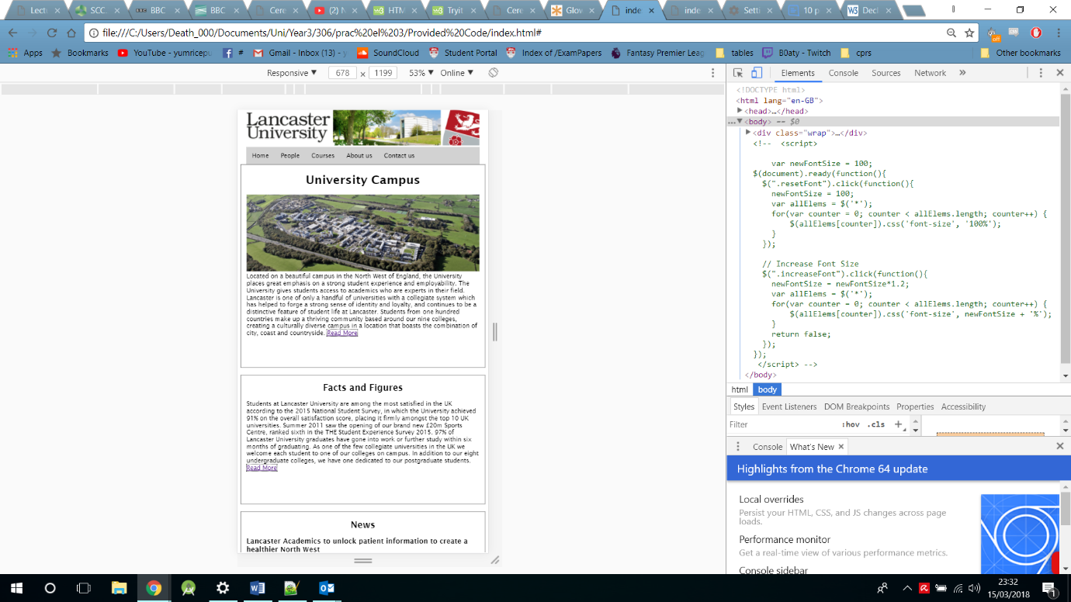

These screen shots show the display of the site at different resolutions. For mobile, tablet and desktop. Information is kept concise and follows a similar structure. If we look at the original site below this is not of the same standard as the responsive site as horizontal scrolling is required as the text is running off the page.

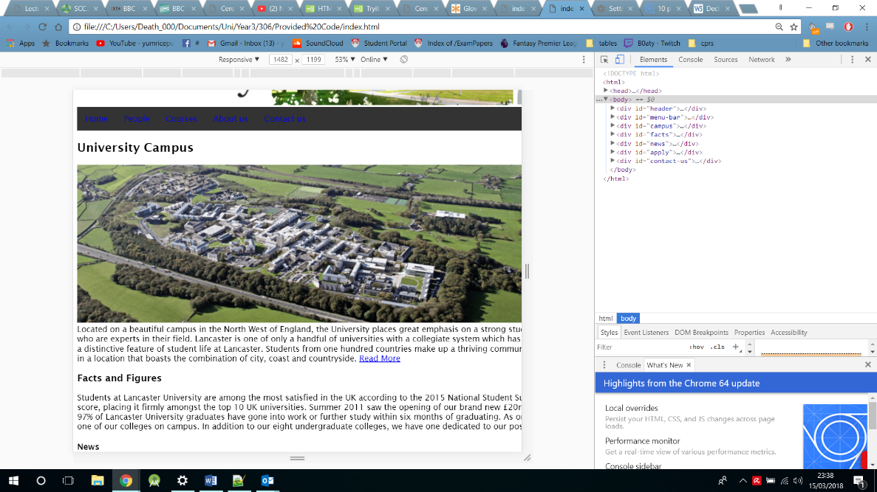

The code below shows each media query and how the columns effect each section of the site. This CSS is then implemented in to certain div tags to sectioning these areas off with bordering.

